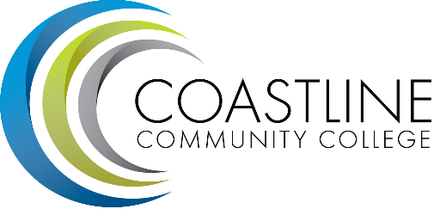
College Council Committee Agenda
September 12, 2017; 9:00 – 11:00 a.m.
President’s Conference Room, College Center

Committee Mandate: To act on College committee and constituency recommendations, to foster College communication and information sharing, and to review overall College operations.

- CALL TO ORDER
  - Roll Call
  - Welcome
  - Adoption of **Agenda

- SPECIAL REPORTS/UPDATES
2.1 Constituency Updates
Associated Student Government (Carlos Bahena)
Academic Senate (Stephen Barnes)
Classified Senate (Kevin Donahue)
Management Team (Lori Adrian)

2.3 College Event Calendar
- Movie Night, September 15, 2017, Newport Beach Campus.
- EOPS Toy Drive, Oct 2-Nov 1, 2017
- Classified Senate Fall Festival, October 27, 2017, 12:00-1:30 p.m., College Center patio

- PRESIDENT/VPs Brief Reports (Adrian, Groot, Miyashiro, Nguyen, Rodriguez) (1-2 min)

4. ACTION ITEMS

5. STANDING REPORTS
  - Budget Update (Christine Nguyen)
  - PIEAC (Stephen Barnes/Vince Rodriguez)
  - *Program/Department Review (Stephen Barnes/Aeron Zentner)
  - Student Success Committee (Ross Miyashiro)
  - Facilities, Safety & Sustainability (FSS) Committee (Christine Nguyen)
  - Technology Committee (Christine Nguyen)
  - Accreditation (Vince Rodriguez)
  - Financial Aid Federal Program Review
  - Student Scorecard/Student Achievement Data
  - Guided Pathways

6. DISCUSSION ITEMS
6.1 College Committee List 2017-18
6.2 College Council Goals (Lori)

7. ANNOUNCEMENTS

- SUMMARY OF KEY ITEMS DISCUSSED/ACTIONS TAKEN
8.1 Report on Accreditation (list accreditation standards)
8.2 Submit Accreditation report by November 2018

- ADJOURNMENT
9.1 Items for next meeting:
*Attachment has been emailed.
**Attachment available at meeting.

